**Grafana Network Input/output dashboard.**

Below is the Dashboard Screenshot which I added.

I created this dashboard for the monitoring of Network Input / Output. And see the fluctuation between the pods.

**Overview for every single dashboard.**

Will start with the First one.

**Current Rate of Bytes Received.**

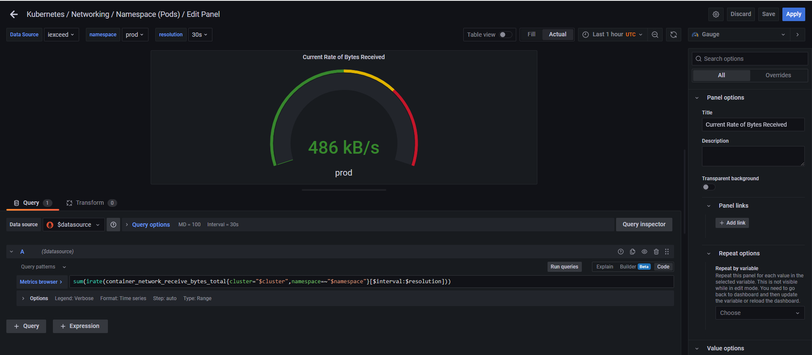

Above is the “Edit panel” of the Dashboard.

* Here you can select the metric as per the scenario.

**For Ex:-** If you must create the Dashboard for **“CPU Usage”** then accordingly you have to select the metric for creating the dashboard.

* Most Important points are :-
  + You need to be sure which **“data source”** you are going to be used.
  + Most of the Time you may need to perform the mathematical operation in the query. **For Ex. You have “Total Allocated Ram & Total Available Ram”.**
  + Then how you can find the **“Total used Ram”.** For that you need to Subtract both the Values then you can see the value which you want, and you can display it multiple types of dashboards.



* The above Dropdown which you can see is kind of Filters which we us in Excel is known as variables in Grafana.
  + We need to create this then only you can see it on the Top of Dashboard. (Refer to the full screenshot you can see them.)
  + For Creating this follow the steps below.
  + 

You can select the timespan for how many days or hours data you want to see.

Click on this icon. You can see this on the top right corner.

Saving the dashboard

This is for add a new dashboard.

* + On the Left-Hand side, you will see variables, Click on it. (Refer the Below screenshot).

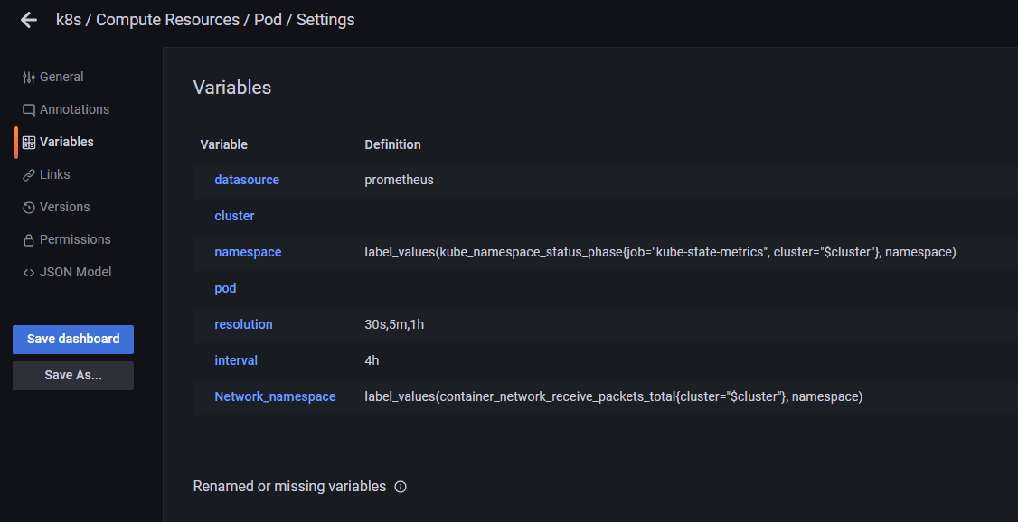

* + We can create the variable and add respective definition inside the Variable.

Below is the Screenshots of Different Dashboards. Which you can refer and create your own new dashboard.

**Current Rate of Bytes Transmitted**

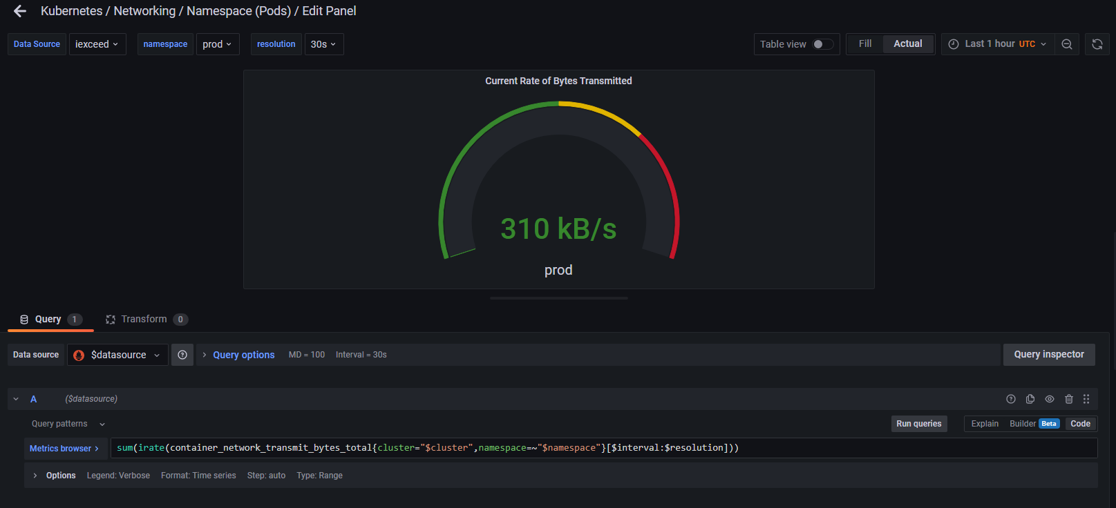

**Current Status for PODS.**

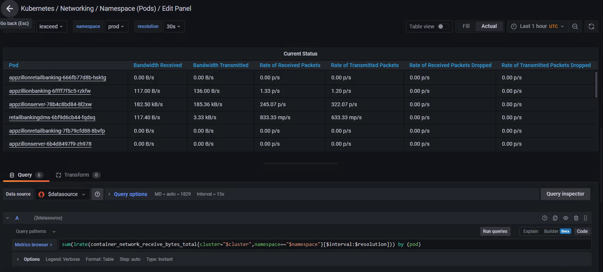

* Above is the Screenshot for another type of Dashboard in which we can create a table in which we can show the details as the above Screenshot is displaying.
  + It is a Self-understandable Dashboard.
  + Under Pod there is a list of Pods which is running in **“iexceed” datasource & namespace is “prod”.** You can see these details on the top of the above screenshot.
  + All the details are given with respect to Bandwidth, Packets received, Dropped, Transmitted etc.

**Receive Bandwidth**

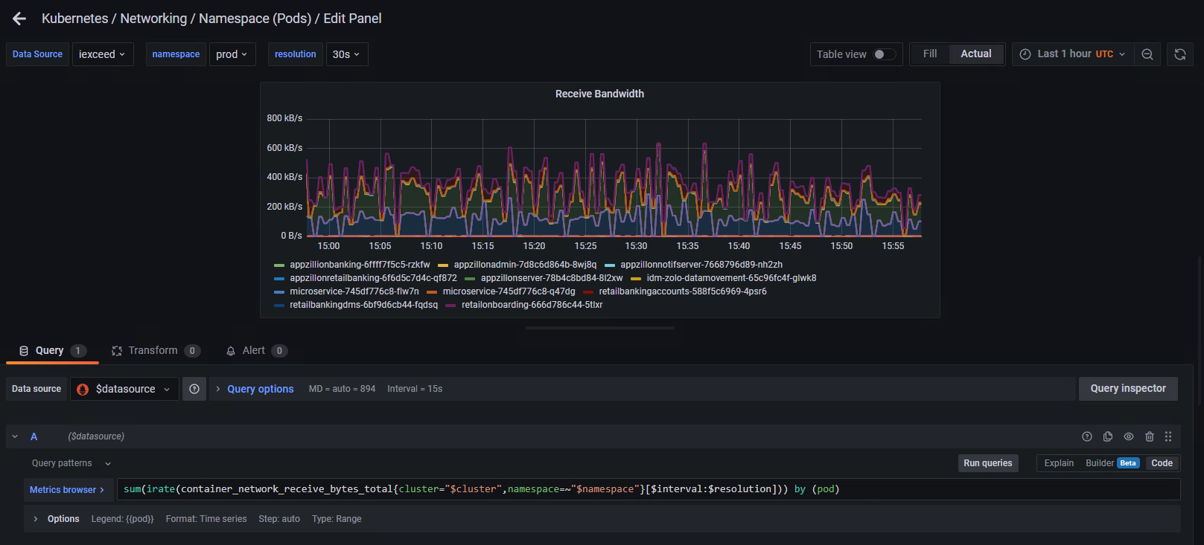

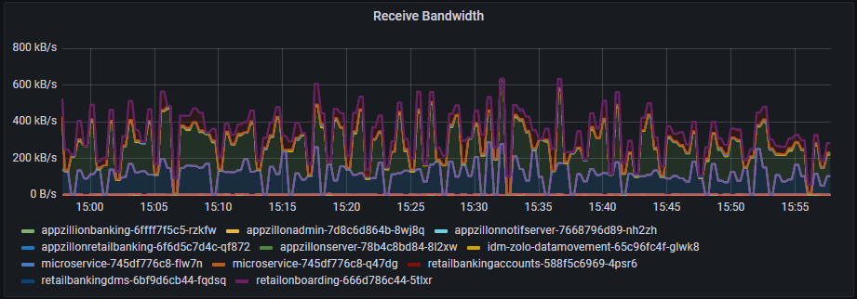

These are the Pods with the Colour Graph Lines. If you want to see the graph for the specific POD, just click on any of the POD’s it will give you the Graph. (Refer the below the Screenshot for the same).

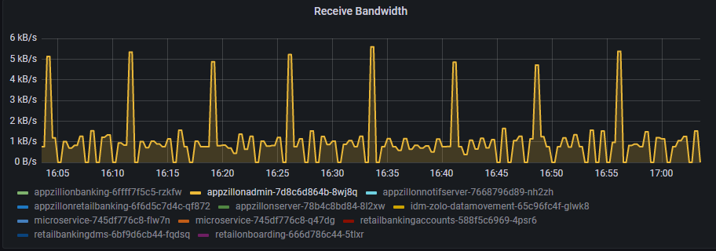

I selected this Pods, and you can see the graph for it.